“Introduction to Psychology” Subject Pool
Department of Psychology
New Application for Participant Hours

Experimenter’s name: Michael Lopez-Brau
Email address: michael.lopez-brau@yale.edu
Phone number: (203) 432-5961
Campus address: 1 Prospect St, New Haven, CT, 06511, Room 206
Advisor’s name Julian Jara-Ettinger
Title of Study Image Inference

Researcher Status: Undergraduate senior project
(Check one) Other undergraduate project
Graduate dissertation project
Other graduate student project X
Postdoctoral fellow
Faculty

X Check this box to confirm that this study has already been submitted for approval by the Human Subjects Committee. (Studies that have not yet been submitted to the HSC will not be evaluated for inclusion by the “Intro to Psychology” subject pool. Studies that have been submitted to the HSC but which have not yet received approval may still be evaluated, but the evaluation committee may also opt to delay its evaluation until HSC approval is granted (at which point our evaluation will occur on an expedited schedule).

HSC Protocol # 2000020187 (Provide the approved protocol number, or list as “pending” and provide the date the application was submitted to HSC)

Title of FAS-approved project:

Conceptual Development
Number of hours requested: 40
Minimum number of allotted hours needed to launch the experiment: 40

Please be as accurate and conservative as possible. The total number of allocated hours may be considerably less than the number of hours requested due to exceptional demand and limited supply. Please provide a minimum number of hours that you would accept in order to still run your experiment in the subject pool this semester in case we are unable to provide all experimenters with the requested number of hours.

Advertised length of each experimental session (select one): 30 minutes or 60 minutes

Faculty advisor’s name: Julian Jara-Ettinger (If applicable)
Faculty advisor’s signature: Date:
Experimenter’s signature:  Date: 09/02/2019

Advisor approvals may also be indicated by emails to psychsubject.pool@yale.edu. These should specify the experimenter’s name and the title of the study.
Please carefully read the instructions for the new applications in the Intro to Psych Subject pool Dropbox, and respond to the following four sections:

- Procedure:
[Describe in detail what a participant will do in your study from the beginning to end.]

Participants will be presented with an introduction that outlines the general layout of the stimuli and other features of the task and a quiz that checks their understanding. Upon passing the quiz, participants will be presented with 23 trials in random order. Each stimulus is embedded within a “gridworld” and contains some cookie crumbs an agent left behind, three labeled corners (i.e., the goals), and up to three labeled doors (i.e., the entrances). Participants will have to use the cookie crumbs to infer (1) which goal the agent was going for and (2) which door they came from. We will record their judgments by asking them to draw the path they think the agent took.

The experiment, including the briefing and consent process, will take 30 minutes to complete. Once the task is finished, we will ask them some questions about the task (e.g., “What made you draw this path over other paths?”). Then, we will debrief them and explain that the purpose of our study is to examine our ability to make rich social inferences (e.g., actions and desires) from just a single image.

- Online SONA description:
[Provide three to five sentences which will be used to advertise your study on SONA systems.]

Ex)

Social Reasoning Study
In this experiment, you’ll see some pictures of a room with some cookie crumbs somewhere on the floor. For each picture, you’ll have to figure out where someone was trying to go based on where the cookie crumbs are.

- Data collection plan: Please respond to the following questions:

  - Are you ready to start testing participants immediately upon the opening of the Intro Subject Pool (September 18th), if your study is accepted?
No

  - If not, at what point in the semester will you be prepared to start testing participants?
October 21

- Informed Consent Form:
[You can attach your Informed Consent form or include here]

- Debriefing:
[Insert here or attach your debriefing form.]

Study Debriefing

Thank you for participating in our experiment today.

Though much of the natural word is dynamic, humans are well-equipped to make rich inferences from static scenes. Seeing someone standing in line at a clothing store with a single piece of bright clothing, we can immediately reconstruct several potential paths they took to get there: perhaps they entered, knew what they were looking for and walked straight there, and then browsed for a bit in that section before picking something out. How are people able to infer the desires and previous actions of agents from seemingly little information?

Hypothesis and main questions
Research has shown that people can infer an agent’s goal by watching how they act (Baker, Saxe, & Tenenbaum, 2009). These models take as input a set of actions, and infer the goal by assuming that the agent was navigating efficiently in space. We hypothesize that this same expectation also allows people to infer agents’ goals even in situations where agents are not present and there are no actions to be observed. Specifically, we hypothesize that, when given indirect evidence that an agent was in a certain position in space, people can infer where the agent came from and where they were going by assuming that this state falls within an efficient trajectory in space.

How was this tested?
In this experiment, you had to draw the path you think the agent took to get to/from their goal. Your answers will be compared against those from a computational model that generates and evaluates potential paths the agent could’ve taken.

Why is this important to study?
First, studying this cognitive capacity will enable us to better understand how we reconstruct events (e.g., is it due to a rich, generative model or instead grounded in heuristics and associations?) Second, understanding how this capacity would provide new methods for building better intelligent machines.

What if I want to know more?
If you have any further questions about the procedure or scientific aims of the work, please do not hesitate to contact me at michael.lopez-brau@yale.edu If you are interested in learning more about how we make inferences from others’ actions, see:

Baker, C. L., Saxe, R., & Tenenbaum, J. B. (2009). Action understanding as inverse planning.
Cognition, 113(3), 329-349.

- Certificate from checklist
[After you complete this form, click HERE for the final checklist. Once you complete the checklist, you will receive the checklist. Please take a screen shot of the page, and insert it here.]

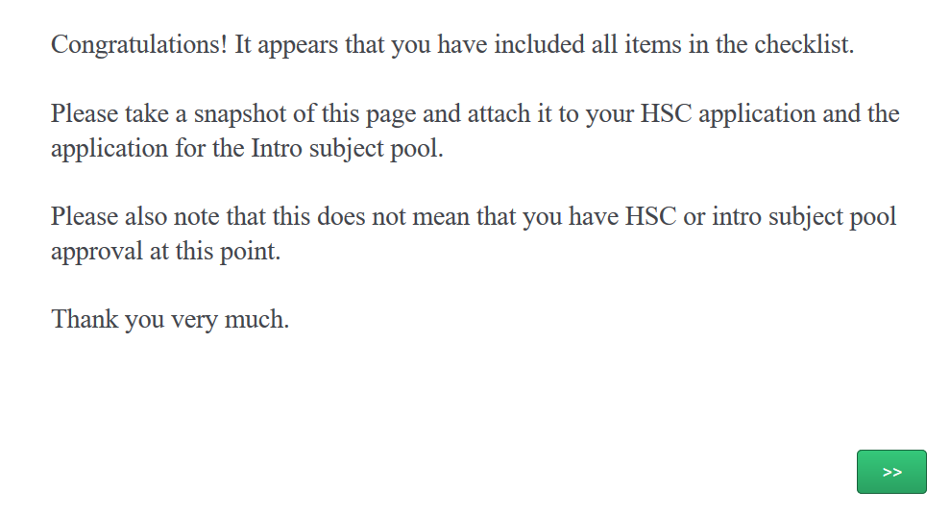

PLEASE SUBMIT YOUR FINAL APPLICATION AS A SINGLE PDF

